**Compile&run**

Befor compiling the software you have to make sure you got the WIGLE WIFI file on your computer. After you run the software you will see the next window:

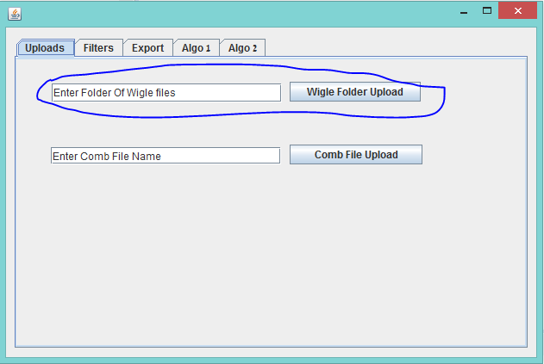

In the marked box you should put the **path** of your WIGLE WIFI files **folder!** And click the "wiggle folder upload" button.

Now when your WIGLE WIFI files are upload to the software go to "export" tab. You will see the next window:

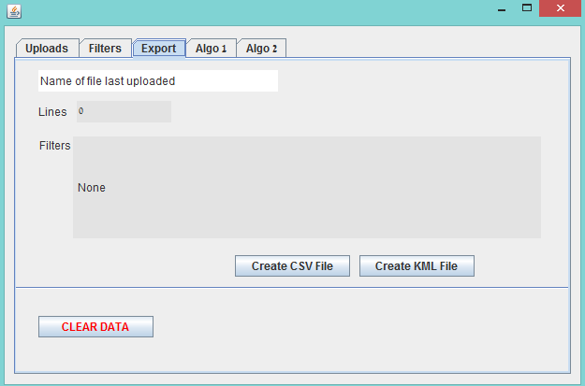

In this window you can create a CSV file or KML file with just one click on the requested button.

In this window you can also see the name of the file you have just uploaded and also can clear the date.

*notice that you can't undo the "clear data" operation.

For making some operation on the file you will want to visit the "filters" or "algo1"/"algo2": tabs.

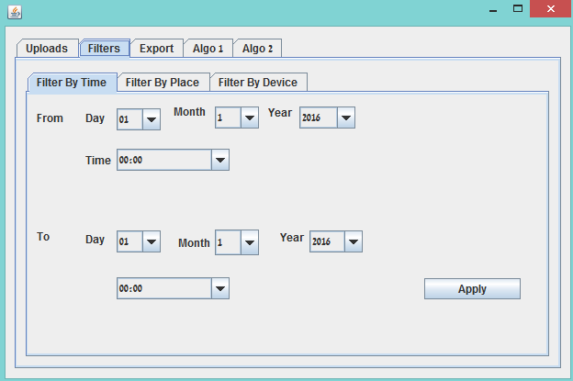

In the filter tab you will see (as show in the image above) 3 filter types, filter by time, filter by place and filter by device.

In filter by time you can choose the start time and end time of the samples of the WI-FI. By clicking apply you will get a new filtered file.

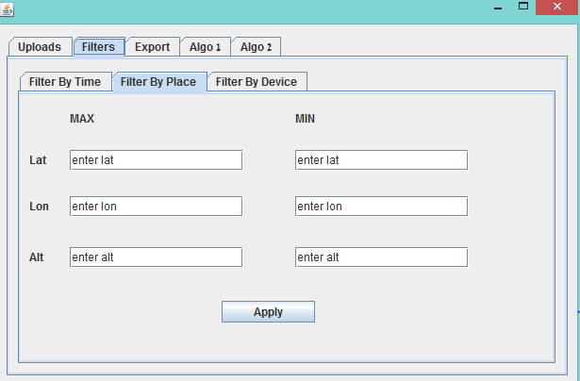

In the filter by place tab you can enter the lat, lon and alt of the requested area in the right places as seems in the image above.

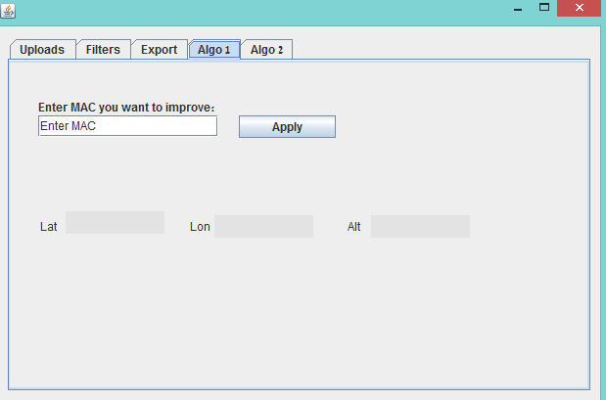

In algo1 and algo2 the result will appear in the window itself.

We made our class in a concept in which every operation will have its own class.

Every requested task from the exercise is in other class. (their may been some similar operation which wrote in the same class like KML and CSV files.)

For example "MyThread" class is all dedicated to the thread in the GUI.

You can see the Collaboration Diagram in the next page.

**Collaboration Diagram**

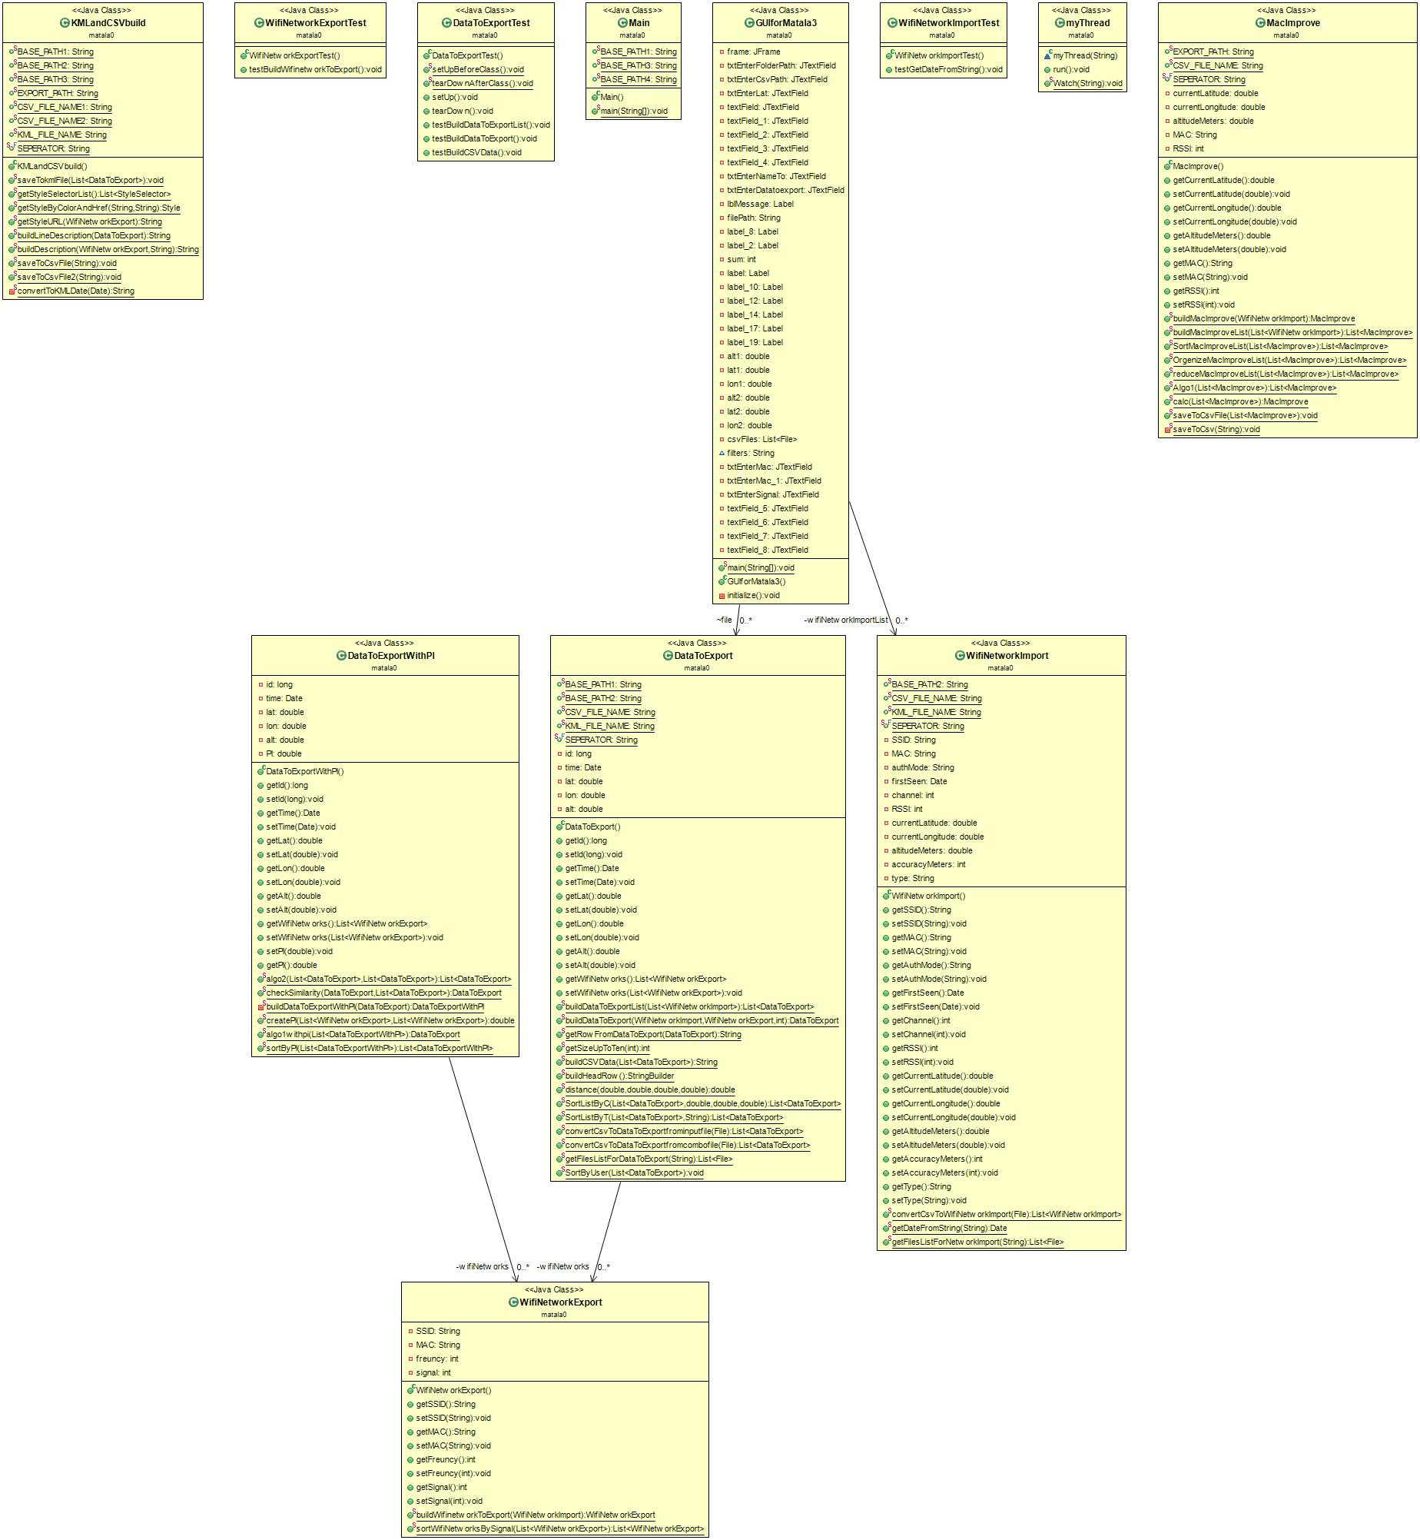

For better view of the diagram you may download the image from our git.